Sound - 06
CLASS 09 - SCIENCE

 | Section A
1 | The cgs. unit of work is:  a) watt  b) joule  c) dyne  d) erg | [1]
2 | In a collision:  a) the momentum of the system is constant  b) momentum is always transferred  c) momentum is always lost  d) energy is lost always | [1]
3 | A boy throws a ball vertically upwards. As the ball rises its total energy (neglect friction):  a) increases  b) decreases  c) zero  d) remains the same | [1]
4 | One joule work is said to be done when:  a) a force of 1 N displaces a body by 1 cm  b) a force of 1 dyne displaces a body by 1 m  c) a force of 1 N displaces a body by 1 m  d) a force of 1 dyne displaces a body by 1 cm | [1]
5 | A tank contains water of mass ’m’ to a height ’h’. The potential energy associated is  a) Zero  b) mgh  c) mg$\frac{h}{2}$  d) Depends on the radius of the tank | [1]
6 | Two inclined frictionless tracks, one gradual and the other steep meet at point A from where two stones (I and II) are allowed to slide down from rest, one on each track as shown in figure. Which of the following statements is correct? 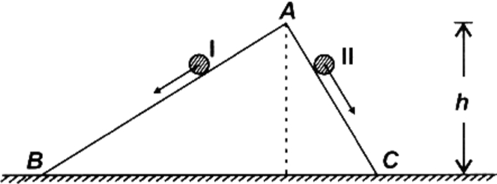  a) Both the stones reach the bottom at the same time but not with the same speed.  b) Both the stones reach the bottom with the same speed and stone II reaches the bottom earlier than stone I.  c) Both the stones reach the bottom at different times and with different speeds.  d) Both the stones reach the bottom with the same speed and stone I reaches the bottom earlier than stone II. | [1]
7 | S.I. unit of power is ________.  a) J/s  b) s/J  c) Js  d) Js$​^{2}$ | [1]
8 | Water stored in a dam possess  a) Potential energy  b) No energy  c) Electrical energy  d) Kinetic energy | [1]
9 | If a body is stored at a height h then it will possess:  a) Both potential and kinetic energy  b) Potential energy  c) Kinetic energy  d) Work | [1]
10 | A box of 5 kg mass moves up a ramp from point A to point Bat a constant speed. Given that the surfaces are smooth (frictionless). What is the gain in the potential energy by the box? (g = 10 m/s$​^{2}$ ) 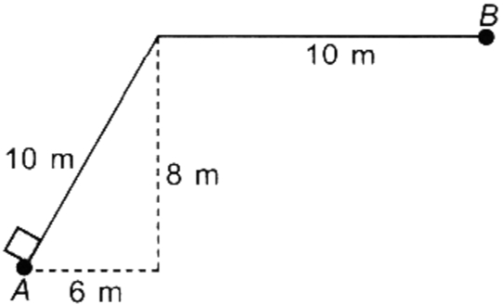  a) 400 J  b) 100 J  c) 200 J  d) 220 J | [1]
11 | Statement 1 : If a light body and a heavy body possess the same momentum, the lighter body will possess more kinetic energy. Statement 2 : The kinetic energy of a body varies as the square of its velocity.  a) Both statements 1 and 2 are true and statement 2 is the correct explanation of statement 1.  b) Both statements 1 and 2 are true but statement 2 is not the correct explanation of statement 1.  c) Both statements 1 and 2 are false.  d) Statement 1 is true but statement 2 is false. | [1]
12 | A mass m is moving in a circle of radius 1 m with a uniform speed of 5 m/s. The work done when its radius turns by 60$​^{o}$ is:  a) zero  b) 10 joule  c) 2.5 joule  d) 5 joule | [1]
13 | A total of 4900 J was spent in lifting a mass of 50 kg. the mass was raised to a height of:  a) 10 m  b) 245,000 m  c) 960 m  d) 98 m | [1]
14 | A microphone converts sound energy to:  a) A pulse  b) Sound energy  c) Electrical signal/energy  d) A wave | [1]
15 | An object of mass 1 kg has a potential energy of 1 joule relative to the ground when it is at a height of:  a) 1 m  b) 32 m  c) 9.8 m  d) 0.102 m | [1]
16 | No work is done when:  a) textbook is lowered diagonally at a constant velocity  b) there is no component of force, parallel to the direction of motion  c) a box is pushed along horizontal floor  d) a nail is hammered into a wooden box | [1]
17 | An object of mass 5 kg falls from a height of 5 m above the ground. The loss of potential energy of the mass is:  a) 245 J  b) 25 J  c) 50 J  d) 2.5 kJ | [1]
18 | Two masses m and 2m are dropped from a certain height ’h’. Then on reaching the ground,  a) K.E. of the lighter is 4 times the K.E. of the heavier  b) K.E. of the heavier is 4 times the K.E. of the lighter  c) K.E. of the heavier is more than that of the lighter.  d) K.E. of them will be equal | [1]
19 | The work done by a force on a body will be positive if the:  a) body moves perpendicular to the direction of motion  b) body moves opposite to the direction of the applied force  c) the body moves along the direction of the applied force  d) body does not move | [1]
20 | The work done on an object does not depend upon the  a) Displacement  b) Angle between force and displacement  c) Initial velocity of the object  d) Force applied | [1]
 | Section B
21 | Work done is said to be negative if the applied force has a ________in the direction opposite to displacement.  a) energy  b) position  c) component  d) compliment | [1]
22 | Kinetic energy depends upon the ________and the square of ________of a body.  a) newton, metre  b) mass, velocity  c) velocity, newton  d) mass, metre | [1]
23 | A body is thrown vertically upwards, during its rise the P. E ________and K.E ________.  a) decreases, increases  b) remains same, remains same  c) increases , increases  d) increases, decreases | [1]
24 | Instantaneous power is the product of force and ________.  a) volume  b) velocity  c) mass  d) energy | [1]
25 | The centre of _________ is a point, where the total upthrust, due to fluid displaced by part ____________ of body acts.  a) buoyancy, the immersed  b) gravity, the immersed  c) gravity, buoyancy  d) gravity, immerse | [1]
26 | If the cuboid is mounted on the top of an inverted pointed object, the pressure exerted by the set - up on the sand ________.  a) decreases  b) increases  c) can’t say  d) remains same | [1]
27 | A fish ________ by squeezing out air, from its ________.  a) dives, floating tube  b) dives, float  c) float, lungs  d) lungs, float | [1]
28 | The ________of a body to do work is called energy.  a) energy  b) height  c) capacity  d) work | [1]
29 | 60 W means that the device will use 60 joules of energy in ________ hour.  a) $\frac{1}{360}$  b) 3600  c) $\frac{1}{60}$  d) $\frac{1}{3600}$ | [1]
30 | When a coil spring is compressed, the work is done in the spring. The elastic potential energy ________.  a) decreases  b) disappears  c) re - mains unchanged  d) increases | [1]
31 | The combined weight of the sinker and cork is ________ than the weight of the sinker alone.  a) less  b) zero  c) much  d) more | [1]
32 | Work done is said to be zero if the applied force is ________to the direction of displacement.  a) perpendicular  b) power  c) joule  d) mass | [1]
33 | Work done is said to be positive if the applied force has a ________ in the direction of displacement.  a) energy  b) power  c) component  d) displaces | [1]
34 | 1 W. S = ________?  a) 10 joule  b) $3.6×10^{6}$ joule  c) 2 joule  d) 1 joule | [1]
35 | When a body is partly or wholly immersed in a ________experiences an ________.  a) fluid, upthrust  b) buoyancy, fluid  c) fluid, fluid  d) fluid, buoyancy | [1]
36 | Work is said to be done if a force ________a body through a certain distance in the direction of the force.  a) displaces  b) position  c) work  d) energy | [1]
37 | The point of maximum K. E in case of oscillating pendulum is ________position.  a) Same at both position  b) Extreme  c) Mid print of mean and extreme  d) Mean | [1]
38 | An iceberg floats with _________ of its volume below ________.  a) $\frac{11}{12}$ , $\frac{10}{12}$  b) $\frac{11}{12}$ , water  c) water,$\frac{10}{12}$  d) water, water | [1]
 | Section C
39 | Which of the following statement are incorrect  - A bird sitting on tree possess potential energy only  - A stationary object may have energy  - A flying bird has kinetic energy only  - An aero plane running on the run - way possess kinetic & potential energy both  a) A, B, C and D  b) B and D  c) C and D  d) A and C | [1]
40 | Find the incorrect statement  - The P. E of a freely falling object increases progressively.  - Body at rest may possess energy.  - There is no transfer of energy between you and the rock when you push a huge rack and fail to move it.  - K.E. is converted into heat and sound energy when a freely falling object eventually stops on reaching the ground.  a) D  b) B  c) C  d) A | [1]
41 | When an object starts to fall freely, which statement is incorrect about it?  - Its potential energy is increased and kinetic energy is decreased  - Its kinetic energy is increased and potential energy is decreased  - Potential energy remains unchanged  - Kinetic energy remains unchanged  a) A, C and D  b) A and D  c) A, B, C and D  d) B and C | [1]
42 | When an object starts to fall freely, which statement is incorrect about it  - Its potential energy is increased and kinetic energy is decreased  - Its kinetic energy is increased and potential energy is decreased  - Potential energy remains unchanged  - Kinetic energy remains unchanged  a) All of these  b) (B) and (C) are correct  c) (A) and (B) are correct  d) (A), (C) and (D) are incorrect | [1]
43 | Which of the following statement are incorrect  - A bird sitting on a tree possesses potential energy only.  - A stationary object may have energy.  - A flying bird has kinetic energy only.  - An aeroplane running on the run - way possesses kinetic & potential energy both.  a) A, B, Cand D  b) A, Band C  c) C and D  d) B and C | [1]
 | Section D
44 | To compare the pressure exerted by the solid iron cuboid, a student took two cuboids having the same dimension and the same nature of the material. After performing the experiment with both the cuboids, she found:  a) p$​_{1}$ = 2p $​_{2}$  b) p$​_{2}$ = 3p $​_{1}$  c) p$​_{1}$ = p $​_{2}$  d) p$​_{2}$ = 2p $​_{1}$ | [1]
45 | On a school trip to Rohtang pass, Manali, student A wears wide base shoes and student B wears narrow base shoes while walking on the ice. Who will be able to walk easily and comfortably if both the students have equal weight?  a) Only student A  b) Only student B  c) Neither student A nor B  d) Both students A and B | [1]
46 | To observe and compare the pressure exerted by solid iron cuboid, a student takes cuboid ’A’ of 5 kg and has the dimension of its base 30 cm$×$ 15 cm and measure its pressure. Then she mounts another cuboid ’B’ is of 1 kg in weight having dimensions 30 cm $×$ 15 cm $×$ 2 cm standing vertically upright on the cuboid A. Now for the new set - up.  a) force increases but pressure decreases  b) pressure remains same  c) force decreases but pressure increases  d) pressure increases with increases in force | [1]
47 | To observe and compare the pressure exerted by solid iron cuboid in its upright position, student ’A’ placed the cuboid gently on the loose sand while ’B’ placed it on the surface of the tabletop. Who will observe the exerted pressure by the cuboid easily?  a) Both students A and B  b) Student B only  c) Student A only  d) Neither A nor B | [1]
48 | To observe and compare the pressure, student A takes the solid iron cuboid while B takes its alloy. Both of them measure the weight of cuboids with the help of a spring balance and find them equal. If both of the students perform the experiment with the face having the same dimensions then they will observe:  a) different pressure in both cases  b) greater pressure in case of student A  c) greater pressure in case of student B  d) same pressure in both cases | [1]
49 | To observe and compare the pressure of solid iron cuboid on the sand, a student stands the cuboid in its upright position on loose sand. The force, that is the weight of cuboid acting on an area equal to the area of its base. When he lies it down:  a) the same force acts on an area equal to the contact area of a cuboid  b) the same force acts on each face of the cuboid.  c) The same force acts on an area equal to the surface area of a cuboid.  d) different forces act on an area equal to the contact area of a cuboid. | [1]
50 | An astronaut performs the experiment "to observe and compare the pressure exerted by solid iron cuboid on sand" in space where gravitational acceleration is zero. He observes that the pressure exerted by cuboid on the sand is:  a) greater than that on the earth’s surface  b) the same as that on the earth’s surface  c) equal to zero  d) less than that on the earth’s surface | [1]
51 | For the greatest and the least pressure exerted by the cuboid in the experiment "To observe and compare the pressure exerted by solid iron cuboid on san while resting on its three different faces" the position of cuboid should be:  a) upright, side base  b) widest base, side base  c) upright, widest base  d) widest base, upright respectively | [1]
52 | To show that the effect of force depends upon the area of contact, a student holds both the ends of sharpening pencil between the index fingers of both the hands and presses it from both sides. The finger which has a deeper mark of a pencil is:  a) on thumb of both the hands  b) towards the flat end of the pencil  c) on forefinger of both the hands  d) towards the pointed end of the pencil | [1]
53 | To observe and compare the pressure exerted by the solid iron cuboid on the sand, two students take the different solid iron cuboid having the same weight but different dimensions. After performing the experiment:  a) the same conclusion is drawn by them  b) the conclusion can be determined by making the dimension the same  c) none of the students draw any conclusion  d) a different conclusion is drawn by them | [1]
54 | An iron sphere of mass 10 kg has the same diameter as an aluminium sphere of mass is 3.5 kg. Both spheres are dropped simultaneously from a tower. When they are 10 above the ground, they have the same  a) Potential energy  b) Kinetic energy  c) Acceleration  d) Momenta | [1]
 | Section E
55 | Give three examples when the object is not displaced in spite of a force acting on it. | [2]
56 | The weight of a person on a planet A is about half of that on the Earth. He can jump up to 0.4 m high on the Earth. How high can he jump on planet A? | [2]
57 | The potential energy of a freely falling object decreases progressively. Does this violate the law of conservation of energy? Why? | [2]
58 | The diagram below shows a pendulum which was released from position A. 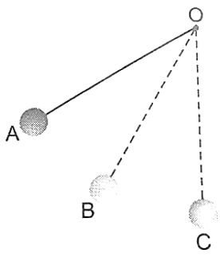  - What form(s) of energy did the pendulum have at  - A?  - B?  - C?  - Eventually, the pendulum would stop moving. Explain what has happened to the initial energy of the pendulum. | [2]
59 | A man rowing a boat upstream is at rest with respect to the shore. Is he doing work? | [2]
60 | A ball is dropped from a height of 10 m. If the energy of the ball reduces by 40 per cent after striking the ground, how high can the ball bounce back? (g = 10 ms$​^{−2}$ ) | [2]
61 | Justify giving proper reasoning whether the work done in the following cases is positive or negativea) Work done by a man in lifting a bucket out of a well by means of a rope tied to the bucket b) Work done by gravitational force in the above case. | [2]
62 | The power of a motor pump is 2 kW. How much water per minute the pump can raise to a height of 10 m? (Given g = 10 m s$​^{–2}$ ) | [2]
63 | In each of the following a force, F is acting on an object of mass, m . The direction of displacement is from west to east shown by the longer arrow. Observe the diagrams carefully and state whether the work done by the force is negative, positive or zero. 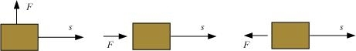 | [2]
64 | How is the power related to the speed at which a body can be lifted? How many kilograms will a man working with the power of 100 W, be able to lift at constant speed of 1 ms$​^{−1}$ vertically? (g = 10 ms $​^{−2}$ ) | [2]
65 | Calculate the work required to be done to stop a car of 1500 kg moving at a velocity of 60 km/h? | [2]
66 | A woman pulls a bucket of water of total mass 5 kg from a well which is 10 m deep of 10 m in 10 s, Calculate the power used by her. (Take, g = 10 ms$​^{−2}$ ) | [2]
67 | A stone is thrown vertically upward with an initial velocity of 40 ms$​^{−1}$ . Taking g = 10 ms $​^{−2}$ , find the maximum height reached by the stone. What is the net displacement and the total distance covered by the stone? | [2]
68 | Certain force acting on a 20 kg mass changes its velocity from 5 ms$​^{−1}$ to 2 ms $​^{−1}$ . Calculate the work done by the force. | [2]
69 | What is the relationship between the commercial unit and SI unit of energy? | [2]
70 | Whyan egg sinks in fresh water but floats in a strong solution of salt? | [2]
71 | A body moves along a circular path. How much work is done in doing so? Explain. | [2]
72 | A man of mass 60 kg runs up a flight of 30 steps in 15 seconds. If each step is 20 cm high, calculate the power developed by the man. (Take g = 10 m/s). | [2]
73 | If the power of a motor is 40 kW, at what speed can it raise a load of 20,000 N? | [2]
74 | A force of 7 N acts on an object. The displacement is, say 8 m, in the direction of the force given in figure. Let us take it that the force acts on the object through the displacement. What is the work done in this case? 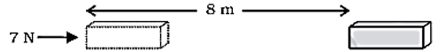 | [2]
75 | Why is the bottom part of the foundation of a building made wider? | [2]

